**An Equine Therapy Experience**

Health, Happiness and Healing through Horses since 1988

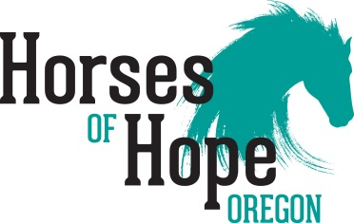

**Volunteer Policy & Procedure Manual**

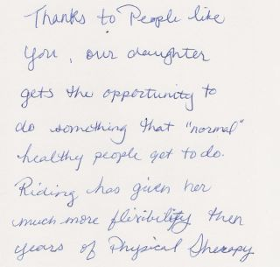

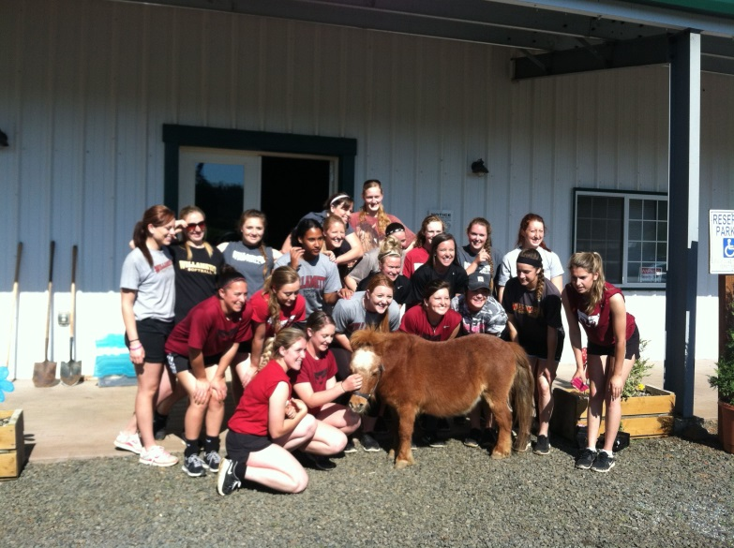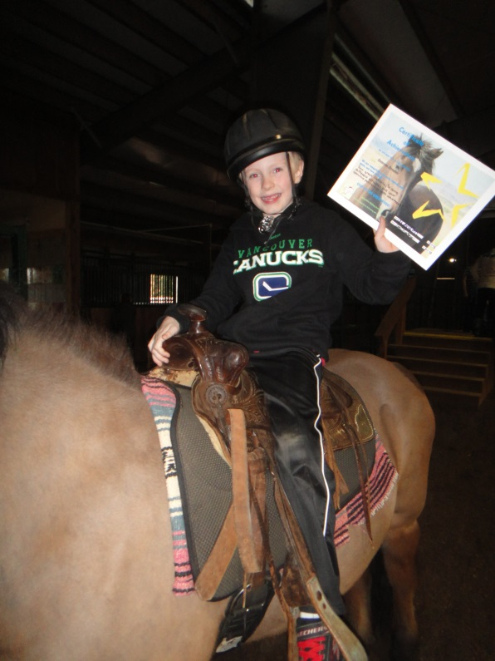

|  |  |
| --- | --- |
| Table of Contents | Page |
| Thank You | 3 |
| Important Numbers | 3 |
| Our Vision | 4 |
| General Information | 5 |
| Disabilities | 15 |
| Volunteer Roles | 16 |
| Emergency Action Plan | 17 |
| Ways to Be a Better Volunteer | 19 |

**An Equine Therapy Experience**

Health, Happiness and Healing through Horses since 1988



*Thank you!*

YOU are such an essential part of our success. The programs would not be possible without our dedicated and talented volunteers!

Our goal at HOH is to provide equine-assisted activities for individuals with emotional, physical, and behavioral challenges. We strive to train our volunteers to assist in program activities that will engage clients in the recreational and healing benefits of adaptive riding. Our services are offered without regard to race, color, ethnic origin, sex, religion, national origin, age, disability, sexual orientation, genetic information or reprisal, or financial status.

We are focused on providing expert volunteer teams burocracy for each client, so that the clients and volunteers can benefit from continuity and establish a lasting relationship of trust. Moreover, we seek to have the volunteer share knowledge, guidance, patience, and compassion with their clients. We offer a professional, safe, and encouraging environment that brings a feeling of boundless joy and endless accomplishments to everyone who enters our stable.

We encourage you to always have open conversations with our staff, which will build a long and happy relationship. In that way, we can provide many hours of service to the deserving population of our community.

**Important contact information:**

OFFICE – 503.743.3890

EMAIL – [info@HOHoregon.org](mailto:info@HOHoregon.org)

Mailing / Stable address – 2895 Cloverdale Drive SE, Turner, OR 97392

Executive Director – Teresa Whalen

Program Coordinator/Instructor – Allie Martin

Assistant Program Coordinator/Instructor – Sadie Denton

Stable Manager – Garrett Mueller

Office Manager – Marjorie Knaus

**OUR VISION**

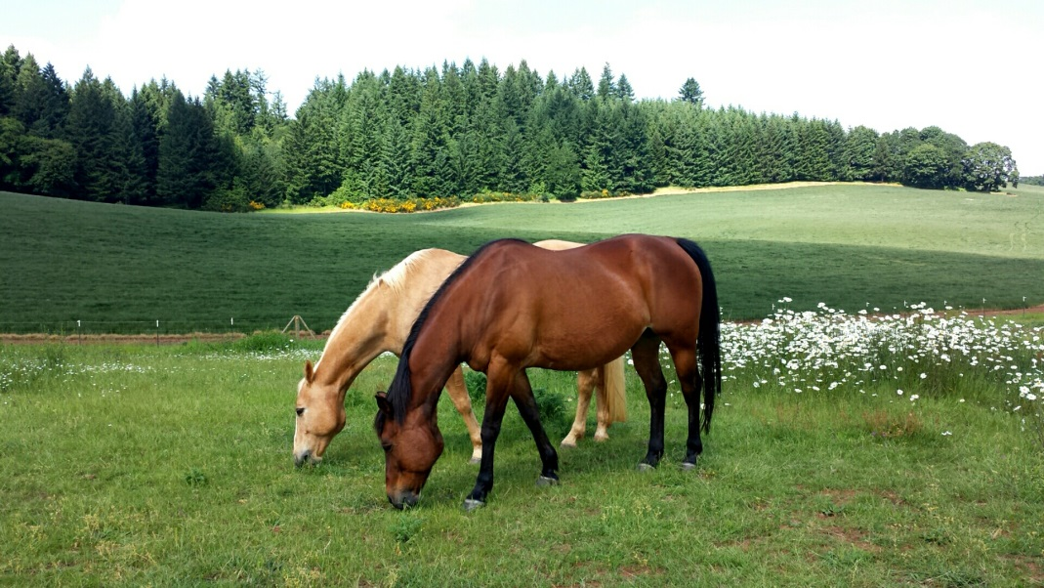

We are a service organization. Our goal is to improve the quality of life of our clients, volunteers, and our community through their interactions with our agency and our therapy horses. We are committed to having the most effective and diverse herd of therapy horses in the State and are devoted to the physical and emotional health of each therapy horse. Additionally, in order to help ease the challenges our client families face by providing a unique and comprehensive blend of support services through equine-assisted therapy we

* have established a creative, thriving community for improving the quality of life for all who enter our stable.
* consciously strive to engage our clients in a fearless approach to creating lasting hope and change.
* continue to step away from tradition and develop new approaches for creating change while facing tough challenges.
* approach this work deliberately – one step at a time with a commitment to transparency.

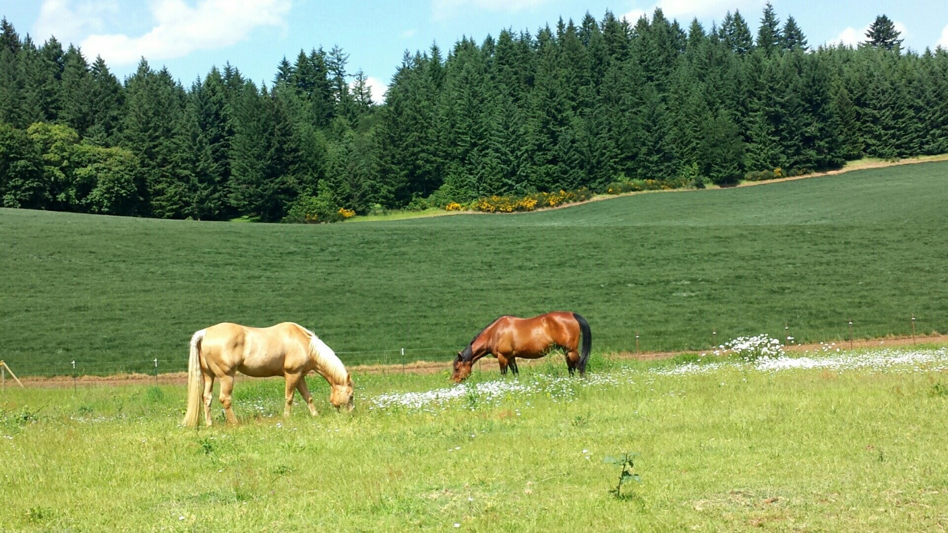

*There is something about the outside of a horse that is good for the inside of a man.*

*- Winston Churchill*

**GENERAL INFORMATION**

**Our Mission**

HOH’s mission is to improve the lives of special needs children and adults through innovative Equine-Assisted Recreational Therapies of the highest quality.

We know that Health, Happiness, and Healing through Horses promote wellness, enhances capabilities and fosters independence. Accordingly, our client-centered programs offer safe and rewarding activities aided by our extraordinary horses, experienced staff, and dedicated volunteers.

**Our History**

HOH was founded in 1988 and is the longest running equine therapy program in Oregon. The original mission of the 501(c)(3) was to provide a wide range of recreational equine services to people, regardless of their physical limitations. Anyone who wanted to experience horseback adventures could. The program was all inclusive of race, color, ethnic origin, sex, religion, national origin, age, disability, sexual orientation, genetic information or financial status.

The early years were filled with wilderness horse packing trips, camping, riding on the beaches of Oregon and exploring mountain trails with adults and children with special

needs. As the Americans with Disabilities Act (ADA) came into focus, Oregon government agencies (BLM, State Park, and the U.S. Forest Service) needed to make upgrades in accessibility to their equine camps and called on HOH to work with Oregon Equestrian Trails and these government agencies on all-access horse camps. In the 1990s, Silver Falls State Park contacted HOH to open an all-access horse rental operation, which operated for about 12 years, serving thousands of people of all abilities from all over the world.

Over the years, HOH continued to grow, with greater demand for services and an increasing numbers of clients, while narrowing its scope and focus on equine-assisted therapy. As more and more requests from the Mid-Willamette Valley were received, the program moved to South Salem, where the number of clients increased four-fold the first year.

In 2012, thanks to the generosity of an incredible benefactor, HOH moved to its current location, our premier 38-acre equine facility, just south of Salem. We are located on the I-5 corridor at “Stalle di Speranza” Stable of Hope and are proud to call this home. Our spacious facility, measuring 36,000 square feet, is home to the endless hope of our dedicated family of staff, volunteers, and horses. Our stable is very welcoming and fully ADA accessible to provide our clients, their families, and caregivers with a place of happiness and healing.

The services we provide include the following:

* Equine-Assisted Therapy
* Equine-Assisted Behavior Modification
* Equine recreation

Services under development include:

* Hippotherapy
* Psychotherapy

Our services are comprehensive and are performed to support the successful growth and development of our goals, clients, and volunteers.

**STABLE RULES**

1. No running.
2. Close all gates and doors behind you.
3. Return things to where you found them.
4. If something is broken, notify a staff person so it can be repaired.
5. Be respectful of everyone, human and animal.

**SAFETY RULES**

1. Staff and volunteers should act in the best interests of the clients: with safety, respect, and privacy.
2. No smoking is allowed on the Stable grounds.
3. All children under fourteen (14) must be supervised at all times.
4. Volunteers may not bring their children without prior approval from staff.
5. Volunteers are discouraged from bringing pets.
6. Helmets should be worn by all persons when mounted.
7. Only tack horses if you have been taught to do so and to use all safety equipment.
8. Only authorized personnel are allowed in the stalls, paddocks, or turnouts with horses.
9. Observe and obey all safety signs.
10. The following activities are forbidden: smoking, drinking by minors, illegal drug use, sexual misconduct or harassment, assault, physical or verbal abuse, or animal abuse.
11. Volunteers should report anything that seems unusual about the people, horses, facility, or equipment to the instructor or staff.



**BE ON TIME**

Remember that the client cannot begin their session without you and they are expecting a timely session. Please remember to sign in and out so that we can always know who is on the property and leverage your volunteer hours for financial support.

**CANCELLATION POLICY**

If you cannot come on your assigned day, please give the staff time to find another volunteer by giving them at least 24 hours. Call the office **503.743.3890.**

Please call the office to check on uncertain weather conditions such as slick or snowy roads.

**WHAT TO BRING**

Please bring a snack and water (please label all water bottles) and you are welcome to put them in the refrigerator if you choose.

**OFF LIMITS TO CLIENTS**

Due to safety regulations, clients are not allowed in the following areas without staff permission and without being accompanied by a staff or volunteer:

* + - Stalls or Paddocks
    - Turnout areas
    - Hay storage area
    - Grain Room
    - Storage areas

**ATTIRE**

We ask that your appearance be neat. You are invited to dress “casual” in a manner consistent with a stable atmosphere. The impression made on clients, visitors and other volunteers and the need to promote safety should be kept in mind. Jeans and t-shirts are fine as long as neither can be seen as offensive to others. Shirts must have non-offensive logos. Shorts are not recommended. Avoid loose fitting clothing and dangling jewelry as they may affect safety. Closed toe shoes must always be worn in the stable area of the facilities. Remember to bring a coat (the stable can get really cold in the winter), and a hat and sunscreen for the summer as our clients ride outside whenever the weather permits.

**CELL PHONE**

**C:\Users\ARI\AppData\Local\Microsoft\Windows\Temporary Internet Files\Content.IE5\DSMYXSBQ\MC900383306[1].wmf**We ask that you leave your cell phone outside of the arena, as they can be distracting while working with clients. We ask that you put your phone on silent or vibrate any time you are at the stable.

**FEEDING THE HORSES**

We ask that you **not feed the horses by hand** nor allow a client, family member, or guest to do so without the assistance of a staff member or volunteer. They will get an appropriate treat for whichever horse you would like to feed.

**NO SMOKING**

**C:\Users\ARI\AppData\Local\Microsoft\Windows\Temporary Internet Files\Content.IE5\8GEH35C6\MC900053957[1].wmf**

**Smoking is not allowed on the property at any time.**

**Please note - This includes electronic cigarettes.**

**Helping Out**

If you have the time, there are always things to help out with around the Stable. Please check the volunteer board or ask one of the staff.

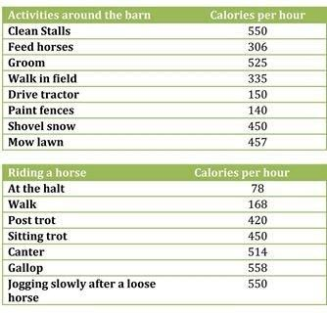

**MINIMUM AGE, INSURANCE, LIABILITY**

No one under the age of 14 is allowed to work with the horses or the clients. However, there are other tasks such as tack and stable cleaning, helping at events, mailings, and landscaping.

Additionally, just being on the property and around horses is potentially dangerous; so, we require every person who enters the stable sign an insurance liability waiver at the front door. This waiver was included in your initial volunteer packet, but in the event you or someone else needs another form, extra forms are at the front door.

**SAFETY AROUND HORSES**

1. Respect the horses. They are big animals.
2. Introduce yourself by speaking softly and rubbing the horse’s neck when you walk up.
3. Always approach a horse where they can see you (not from directly behind).
4. Don’t run or make sudden movements around horses.
5. Don’t duck under the horse’s neck or lead rope.
6. Don’t walk directly behind the horse or stand directly in front of them.
7. Remember to go through a door or gate BEFORE the horse and not beside them.
8. Don’t wrap ropes or reins around your hand or arm.

**CONFIDENTIALITY POLICY**

Clients and their families have a right to their privacy and deserve control over their medical and other sensitive information. HOH supports and preserves the right of all individuals involved in our program.

The staff and volunteers shall keep confidential all medical, social, personal, and financial information regarding a participant and their family.

We know that you will be excited about what happens here but please respect the client’s privacy and share your excitement in such a way that it does not identify the participant.

**INAPPROPIATE PERSONAL CONDUCT**

The instructors are responsible for providing appropriate responses to inappropriate client or volunteer behavior. This is an open communication facility and knowledge of the incident is important to us so that we can handle the situation with care and integrity. Please report any incident to the instructor or staff as soon as possible.

**POLICY AGAINST HARASSMENT**

The organization is committed to providing a work environment free of discrimination. In keeping with this commitment, we maintain a strict policy prohibiting unlawful harassment in any form (verbal, physical, visual, sexual, racial, etc.). Such conduct, whether on or off duty, is also prohibited when it affects an individual creating an intimidating, hostile, or offensive work environment. Those found to have violated this policy will incur disciplinary action, up to and including possible termination.

If you believe you have been harassed by an employee, supervisor, or other person you come in contact with here, you should promptly report the facts of the incident(s) and the name of the individual(s) involved directly to a staff member. If, for any reason, you feel uncomfortable reporting to a staff member, then promptly contact the Board President or Vice-President with your concerns. The organization will investigate all such claims and take appropriate action.

**Harassment is…**

Harassment is a form of misconduct that undermines the integrity of the relationship. Specifically forbidden is harassment of a sexual, racial, ethnic, religious, disability, age, sexual orientation, family medical history, or other protected class or activity-related nature. No volunteer should be subjected to unsolicited and unwelcome conduct in any form (verbal, physical, visual, etc.). Harassment is behavior that is unwelcome and personally offensive, weakens morale, and therefore interferes with our work effectiveness. Such conduct, whether committed by management or non-management personnel, is prohibited. Below, we specify forms of harassment.

Sexual harassment may include offensive sexual flirtations, advances, or propositions; verbal abuse of a sexual nature; graphic or degrading verbal comments about an individual or his/her physical appearance; the display of sexually suggestive objects, pictures, or printed materials; sexual gestures and innuendoes; or any other conduct that has the purpose or effect of creating an offensive environment.

Racial, ethnic, religious, disability- or age-related harassment may include derogatory comments about a person’s ethnic heritage, racial background, religious beliefs, disabilities, or age; the display of objects or printed materials that are degrading to members of particular racial, ethnic, religious, or age groups, or persons with disabilities; racial, ethnic, or religious slurs or name calling; the wearing of insignia supporting racist, religious, or ethnic organizations; or any other conduct that has the purpose or effect of creating an offensive environment.

**EMERGENCY**

In any emergency, follow the direction of the instructor. Exits in the stable are clearly marked with light-enhanced exit signage.

**RIDING THE HORSES**

This is a question that is often asked. Because our focus is on our clients and providing a meaningful experience for them, offering lessons or riding time would be a strain on the horses and the staff. Unless instructed to by a staff, volunteers should not get on a horse before, during, or after a session.

**PARKING**

Please park in front of the stable away from the pond, but avoiding the spaces specifically marked for clients.

**BATHROOM**

Bathroom and laundry facilities are across the aisle from the mounting ramp and are clearly marked. If you notice an issue within the bathroom, please notify a staff member.

**QUESTIONS**

This is a team effort and we encourage an open, honest dialog between staff and volunteers. If you feel uncomfortable discussing an issue with the instructor, please seek out the Executive Director or the Office Manager at any time. We encourage and appreciate your comments.

**OPPORTUNITIES**

We are always in need of help in other aspects of our program. If you are interested in fundraising or in helping with mailings or events, please let us know and we will connect you with the right staff.

**WISH LIST**

We are always in need of the following items:*

Fly Spray

Horse Shampoo

Horse Grain (Senior / Haystack)

Horse Hay (grass hay)

Shavings for Stalls

Office Supplies

Paper towels / Toilet paper

*\*If you are interested, a complete list of needs can be found on our site* [*here*](http://www.adaptiveridinginstitute.org/arihelp.html)*.*

**SPREADING THE WORD**

If you know of an organization that might be interested in more information about our programs, please let the Executive Director know. Also, feel free to spread the word about our amazing organization within your social circle including your church, service organization, and social media.

**TAKE INITIATIVE**

If you see a project that needs to be done and you feel you are qualified, please let the Executive Director know.

**DONATIONS**

As a non-profit, 501(c) 3, we rely heavily on donations to operate our program. Making a donation, sponsoring a stall or a therapy horse is a great way to honor someone’s birthday, anniversary, or to remember someone’s passing. Corporate and individual sponsors should contact the Executive Director.

**ADDITIONAL TRAINING**

If you would like more training in a specific area, please let the instructor know. In order to provide the highest quality of service to our community, we require all volunteers to attend an annual certification course here at the stable.

**VOLUNTEER HOURS**

Logging in your volunteer hours assists us in leveraging grant money through strong documented community support. If you know of anyone who needs community service hours, volunteering at ARI would help to generate those hours. There are opportunities for senior projects or scout projects and 4H clubs, too.

**COMMUNICATION**

Here are a few tips on communication that will make the experience valuable for all.

**Clients:**

1. Try to discuss age related topics with clients; however, be in tune with the fact that some clients have developmental delays and may not respond at age level.
2. Never ‘talk around’ a client or talk about them, but talk ‘to’ them, even if they are non-verbal.
   1. Example: say “Let’s go out on the trail, Johnny,” not “Let’s take Johnny out on the trail.”
3. Remember that too much talking may confuse a client, so don’t ‘parrot’ what the instructor is saying unless asked to do so.
4. Some clients have a goal of increased communication be it verbal or sign language. Be aware of the type of communication the instructor is using.

**Staff:**

1. The staff welcomes your observations and ideas. If there is not enough time to have a private conversation regarding your ideas and or questions regarding a client, please feel free to contact the instructor via email or phone.
2. Please remember that it is not appropriate to discuss confidential or lesson plan information during the session, but the staff is always open to your ideas and opinions.

**CHARACTERISTICS OF A GOOD VOLUNTEER**

|  |  |
| --- | --- |
| **Reliability** | Regular attendance, adequate notice |
| **Punctuality** | Late arrival is frustrating to participants who have been waiting a week for their session |
| **Physical Fitness** | Within reason |
| **Be Relaxed** | An anxious volunteer contributes to a tense mount and a nervous rider |
| **Empathy** | Have empathy and regard, but avoid false sentimentality |
| **Alertness** | Despite always being relaxed, anticipate an emergency |
| **Horse Experience** | Not necessary, but being comfortable around horses is a must |
| **Patience** | Patience is a must to adjust to sometimes slow movements, reactions, or learning of some clients with severe disabilities |
| **Sensibility** | Common sense is a must when dealing with people and large animals |

**THE STABLE**

|  |  |
| --- | --- |
| **Tack Room** | The tack room is organized for easy access to everything we may need. Please help to keep it that way. Return things where you found them. If you find yourself with down time, you can clean up the tack room or clean saddles. |
| **Stalls** | Cleaning and keeping our stable/stalls clean is very important to ARI, as without happy and healthy horses we cannot conduct sessions. It is best to find an experienced volunteer or staff person to show you the technique and the stall cleaning process. |
| **Water** | When you are assigned to water horses, remember that the water may need to be dumped (in the ditch outside of the paddock), buckets cleaned and refilled. |
| **Horse** | Be very careful when moving horses in and out of the stalls, aisles, and wash rack when other people and horses are around. Also, don’t walk behind the horse when grooming or duck under the lead rope. Please keep stalls and wash rack neat and tidy to prevent injury. |
| **Turnout** | Putting a horse in or out of the group turnout can be tricky. Please take a staff member with you for safety when bringing a horse in or out. Parents and clients are not allowed in the turnout areas. |
| **Helmet fitting** | Help ensure that the helmet fits properly before the client is mounted.   1. Helmet should rest two fingers above the eyebrow. 2. Make sure the helmet is centered (front-to-back) correctly. 3. You should be able to slide a finger under the chin strap, but not see daylight. 4. The helmet should sit securely and not rock back-to-front or side-to-side. |
| **Equipment** | All equipment is assigned by the instructor and is listed on the assignment board. Most equipment will already be in front of the horse’s stall. |

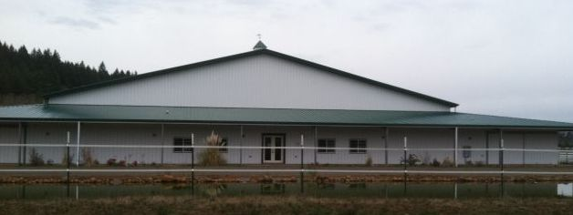

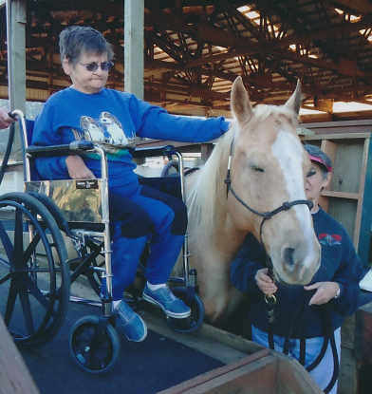**DISABILITIES**

When you meet a person with a disability:

1. Remember to treat that person like everyone else, except for the limitations.
2. Don’t ignore or deny the disability, but show interest in that person as you would any other.
3. Be yourself.
4. Talk about the same things you would with anyone else of that age.
5. HELP ONLY WHEN REQUESTED. Ask permission and then wait for the answer before helping.
6. Be patient – let the person set him/her own pace to accomplish the task. DON’T ASSIST OR DO THE TASK FOR THEM unless asked.
7. Don’t be afraid to laugh with them.
8. Be courteous, supportive, and encouraging.
9. Treat him/her as an equal and give them a chance to prove themselves.
10. The rider may feel insecure; be sensitive to this.
11. Keep an open mind.
12. Enjoy the friendship that will develop between you both as this goodwill can be inspiring to everyone.
13. Please do not physically handle clients without being asked, as this may be detrimental to the rider and/or their progress. Trust the instinct and the knowledge of the instructor.

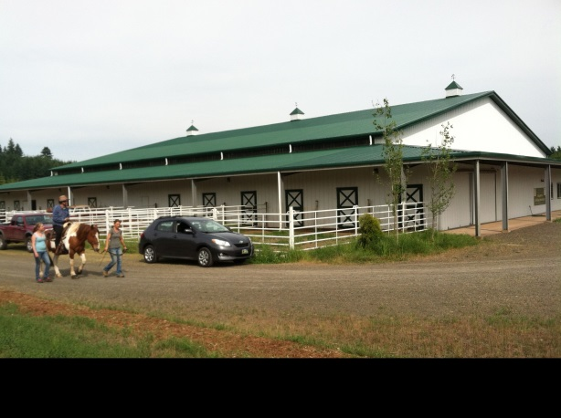 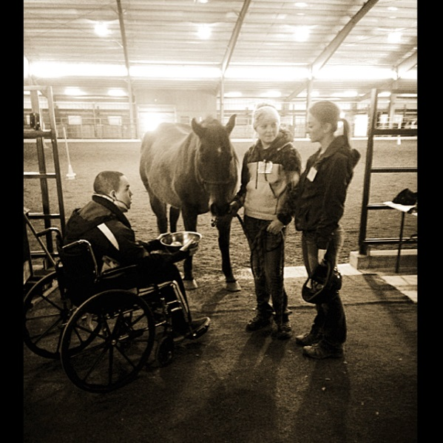

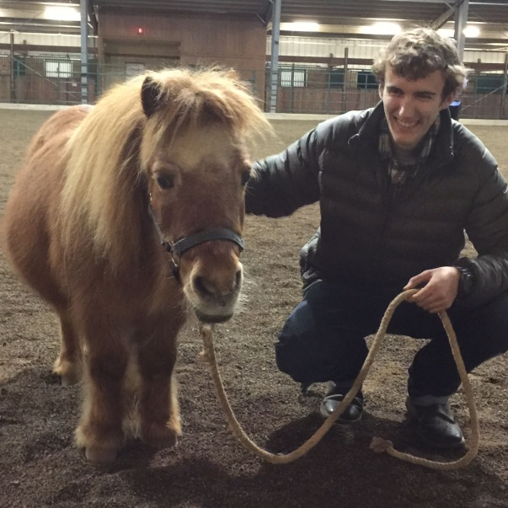

**VOLUNTEER ROLES**

|  |  |
| --- | --- |
| **Horse Leader** | Main responsibility is to focus on the horse – leading and controlling the horse for the lesson. Always check the cinch/girth before the client mounts. The leader must remain aware of the rider, instructor, side-walkers, and any potential hazards at all times. Leaders must also stay very aware of the surrounding areas, what is going on, and how that will potentially affect the ‘team.’ |
| **Side Walker** | Your responsibility is for the client. Please follow the instructor’s direction and your intuition to make this a safe and rewarding session for the client. You may be asked to assist the client with balance or with particular activities. Remember to allow the client time to process the directions given by the instructor and to allow that person ample time to try to accomplish the task on their own or with minimal assistance from you. Be sure you are aware of the proper way to hold or assist each client. |
| **Before the Session** | Arrive at the stable at least 10-15 minutes before your appointed time. This allows you to sign in, put your things away, check the assignment board, and be ready for the session. This time may also be used to prepare the horse for the session. This is a good time to check the goals and abilities of each client that you are assigned to work with (the goal sheet is on the ‘work table’ by the tack room). |
| **Horse & Tack** | Check the assignment board for list of horse, instructor, and other volunteers on your team. Then check to see if that horse is prepared for the session. Help with preparation within your skill level only. |
| **Mounting Procedure** | Make a visual check that the mounting area is safe and free of obstructions. Remember that family members, siblings, and other volunteers may be gathering in the aisle or on the mounting platform. For safety sake, please ask people to clear the area for mounting. |
| **Sessions** | Sessions are led by an instructor or experienced volunteer. For some clients, too much chatter is distracting and impairs their ability to process information. Try to take your cue from the way the instructor is interacting with the client during the session. |
| **After the Session** | Please help put the horse and equipment away as directed by the instructor. |
| **Emergency Procedure** | The horse leader REMAINS WITH THE HORSE AT ALL TIMES even if a client falls off. Follow directions from the instructor, remain calm. The side walkers take direction from the instructor or a senior volunteer as well. (Please read the emergency action plan later in this document.) |

**EMERGENCY ACTION PLAN**

(A full copy of this plan can be obtained in the instructors’ office)

**GENERAL INFORMATION**

The keys to handling almost all emergencies are:

* *stay calm*
* *be prepared*
* *work as a team*
* *maintain good communication*

Being familiar with the emergency guide of ARI will help you be prepared.

**PHONES**

If a cell phone is not within access, there is a landline phone in every office and emergency service can be accessed by calling 911.

**CELL PHONES**

* All staff will have their cell phones at all times.
* Cell phones must be kept on silent during business hours and only used for general business or emergencies.
* Volunteers and staff may use their cell phones during breaks or lunch for personal business.

**MAJOR ILLNESS OR INJURY PROCEDURES**

In case of major illness or injury, staff and/or volunteers are responsible for the following:

1. The staff member will appoint someone to get the nearest first aid kit.
2. The staff will direct volunteers to secure the scene by removing all horses and unnecessary persons from the area.
   1. The other teams will dismount their client as soon as safely possible and return all horses to stalls.
3. Staff will appoint someone to call 911 and to direct emergency personnel to the exact location. The person calling 911 must:
   1. Stay calm and stay on the line until dispatch tells you to disconnect.
   2. Provide information pertinent to the incident including the nature of the incident, number of victims and their condition, and the treatment given.
   3. Remember that horses spook easily and ask emergency service that sirens be silenced prior to arrival.
4. If the injured is a participant, staff, or volunteer, someone will be instructed to get their emergency preparedness card and release form from their file and give it to a staff member.
5. A staff member will appoint someone to go and wait by the road to direct the EMS to the exact location of the accident.
6. The instructor or an appointed person will stay with the ill or injured until released by the EMS.

**SESSION EMERGENCY**

1. All horses and team members are to HALT at once.
   1. Leaders stand in front of horse.
   2. Walkers stabilize clients.
   3. Leader calls for and organizes a dismount.
   4. Walkers escort clients to their parents/caregivers.
   5. Leaders and walkers MUST stay calm.
2. This plan may be modified according to the circumstances.

**FIRE PROCEDURES**

In case of fire, smoke or any other reason you may suspect a fire:

1. Call 911.
   1. Give type of emergency and address
2. Personal safety must be your number one priority. Early detection is fundamental to the safety of all persons and horses.
3. Avoid exposure to smoke.
4. Never enter a burning building.
5. In the event of a small fire – extinguish the fire.
   1. Direct someone to the nearest fire extinguisher (there are six and they are signed and located by each main door).

**EVACUATION**

1. Make sure all persons are out of the building and accounted for. Only staff and volunteers may evacuate horses from the stable and ***only when it is safe to do so***.
   1. Horses may be evacuated to turnout or taken to another safe location.
2. Make sure the tack rooms, feed rooms, staff room, and offices are empty and close the doors.
3. Any participant, guest, or volunteer over the age of 18 may leave the property.
4. Any person under the age of 18 will be directed by staff to wait in a safe place while family/caregiver is notified.
5. Arrangements will be made by staff for everyone’s safe departure.

**HIGH WIND, LIGHTNING, HAIL EVENTS**

1. If there is time to travel to a safe shelter, all participants and non-essential staff and volunteers will be instructed to go home.
2. Everyone will be instructed to seek shelter in safe places inside the stable if there is no time to travel.
   1. Leaders will separate students from horses and stay away from high places in case of lightning.
   2. Everyone should be prepared to dismount students in case instructor does not have time to help.

**VEHICLE/EQUIPMENT ACCIDENTS**

1. If someone is struck by a vehicle assess the scene for safety, then approach the scene
2. Traffic should be stopped, tractors shut off
3. Universal and standard First Aid rules should be followed

**WAYS TO BE A BETTER VOLUNTEER**

1. Consider safety first.
2. Treat horses and clients firmly but kindly.
3. Give instructor feedback at appropriate times.
4. Assist your client as instructed.
5. Remain calm in emergencies.
6. Smile often.
7. Acknowledge the efforts of others.
8. Ask a client before touching them.
9. Wear appropriate clothing and shoes.
10. Ask client to do task independently before assisting.
11. Encourage client to thank and touch their horse.
12. Talk to, not through, your client.
13. Support your team.
14. If you are not sure – ask.
15. Stay attentive to the horse, client, other volunteers, and the instructor.
16. If you don’t understand a client, ask for assistance.
17. Be courteous and respectful.
18. Make reference to the person first – not the disability.
19. Do not prejudge a person’s abilities.
20. Listen to, and help the client listen to, the instructor’s directions.
21. To further understand a client observe the eye, mouth, face, and body language as these are all key communicators.
22. Encourage clients to be as independent as possible – even if that means allowing them to fail.
23. Respect everyone’s confidentiality.
24. Bring your positive energy, not your problems, to the client session.
25. Be attentive and keep talking to a minimum.
26. Allow the client the time they need to process the information.
27. Help maintain a safe and welcoming environment.
28. Check clothing under the rider’s leg after they are mounted to make sure it’s not binding.
29. Supervise clients when they are away from their parents/caregiver.
30. Never become too relaxed or distracted to compromise the safety of your client.
31. Always allow clients to share personal information, but don’t ever pry.
32. Any form of injury to yourself or others must be reported as soon as possible.
33. Don’t be fast or loud around the horses.
34. Be aware of the location of phone and first aid.
35. Know your limitations.
36. Sign in and out every time.
37. Do not bring pets or guests without prior approval.
38. Offer physical support to the client only when it is needed.
39. Check the schedule when you arrive so that you are ready on time.
40. Choose your words carefully as they do impact others.
41. Be sober and drug free every time you volunteer.
42. *Have fun, as volunteering should be a rewarding and enlightening experience. Enjoy it!*